**A**

**PROJECT REPORT**

ON

**SWIFT RIDES**

Submitted in partial fulfillment for the award of

**Post Graduate Diploma in Advance Computing**

**(PG-DAC) from**

**INSTITUTE OF EMERGING TECHNOLOGIES**

**Authorized Training Centre**



**Under the Guidance of**

**Savita Vaidya**

**BY**

**Kiran Jare 230945920035 Kiran Dongre 230945920046**

**Prathmesh Mane 230945920056**

**Shubham Wankar 230945920094**



**CERTIFICATE**

This is to certify that the project report entitled **Swift Rides** is a bonfire work carried out by **Kiran Jare, Kiran Dongre, Prathmesh Mane, Shubham Wankar** andsubmitted in partial fulfillment ofthe requirement for the C-DAC ACTS, DAC course in Institute of Emerging Technology in the batch of Sept 2023.

**Savita Vaidya**

**Course Coordinator** **External Examiner**

**ACKNOWLEDGEMENT**

This project **Swift Rides** was a great learning experience for us and we are submitting this work to Advanced Computing Training School (CDAC).

We are very glad to mention the **Savita Vaidya** for her valuableguidance to work on this project. Her guidance and support helped us to overcome various obstacles and intricacies during the course of project work.

Our most heart full thanks goes to ***Mr. Sangram Patil*** **(Director ,IET)** who gave all the required support and kind coordination to provide all the necessities like required hardware , internet facility and extra lab hours to complete the project and throughout the course up to the last day here in C-DAC ACTS, Pune.

**Kiran Jare 230945920035**

**Kiran Dongre 230945920046**

**Prathmesh Mane 230945920056**

**Shubham Wankar 230945920094**

**Abstract**

Swift Rides is a system which reduces the misery of travelers and makes them find cars in short period of time. Swift Rides is an application of finding car in which drivers who are traveling to work, daily commute or occasional trips alone can ask for fellow passengers through our application. For those who use public-transport system to go to work daily can use this application to find drivers who are traveling to the same destination in a short path. It provides with a simple riding platform between the car owner and passengers. This project enables users to access mobility assets own by others exactly when they need. It shows a medium for available cars to pick up them on the interest of car owner with time and capacity.

**Table of Contents**

1. Introduction 4
   1. Document Purpose **4**
   2. Project Background **4**
   3. Aim & Objectives **4**
2. Business Requirements Overview 5
3. Functional Requirements 6
   1. Car owner Module **6**
   2. User Module **6**
   3. Admin Module **6**
4. Non-Functional Requirement 7
5. Use Case Diagram 8
   1. Car owner **9**
   2. User 10
   3. Admin 11
6. Database Design 12
7. Role 12
8. Login 12
9. Users 13
10. Co-passengers **13**
11. Car-company **13**
12. Car-models **13**
13. Vehicles **13**
14. Rides 13
15. States 14
16. Cities 14
17. Payment **14**
18. Booking **15**
19. Passenger-review **15**
20. E-R Diagram 14
21. Snapshots 15
22. Conclusion 20

**List of Figures**

## Use Case Diagrams 17

Fig 1 Car-owner 8

Fig 2 Users 9

Fig 3 Admin 10

Fig 4 ER Diagram 14

# Introduction:

## Document Purpose:

This document communicates the business requirements and scope for developing

Car Pooling System. The scope of this document is to define the functional and non-functional requirements, business rules and other constraints requirements.

## Project Background:

There is a growing awareness of the challenges associated with individual commuting,

such as increasing traffic congestion, rising fuel costs, and environmental concerns.

Inefficient use of private vehicles and the lack of convenient alternatives contribute to these challenges.

## Aim & Objectives:

The online carpooling system is a platform designed to connect individuals who are traveling in the same direction so they can share a ride together. It aims to provide a more sustainable and cost-effective transportation option by reducing the number of vehicles on the road and optimizing the use of existing resources.

# Business Requirements Overview:

* Online car pooling system is the public Web Application.
* User can find out the minimum price ride and then user can send the request to particular Car owner.
* There are mainly two types of users. One is the **Car-owner** and the other one is **Users** who get a ride with car owner.
* Online car pooling system provides the functions which connect the users and the Car owner efficiently and directly.
* Online car pooling system could be maintained by **Administrator**.

Swift Rides Car Pooling system provides such functionalities through which Users can book ride and make ride share with Car-owner who is travelling in that direction.

# Functional Requirements Overview:

Inter-city Car Pooling System consists of three modules described as below.

1. Car owner Module
2. Users Module
3. Admin Module
   1. **Car owner** **Module**
      * Car owner can register and create his own account.
      * Car owner should be able to registered by providing their personal information, vehicle details, driving-license information and contact details.
      * Car owner will have login first before the send the request.
      * Inter-city Car Pooling System provides the function which allows Car owner to publish his travelling details like date, time, price and location.
      * He/she is able to select existing user with their choice.
      * Car owner should have the ability to set their availability by specifying their preferred routes, range of fixation of amount, timings, and the number of available seats in their vehicles.

# User Module

* + - User can register and create his own account.
    - Online car pooling system provides functionality which allows user to find out the rides where he/she wanted to go.
    - User can find out the minimum price ride and then user can send the request to particular Car owner.

# Admin Module

* + - Online car pooling system should provide all function to admin how to handle the System.
    - Admin can had a authority to accepts whole Car owner verified and Users to allow to use the system.
    - What all are the Car owner and Users using this system and are they authorized, valid actual or not all those things are checking the responsibility of admin.
    - Admin had the authority to see the worst review of the users according to that they select the Car owner disabled or blocked.

# Non-Functional Requirement:

* The website should use professional design, look and feel and color scheme.
* Users will have no limitations for accessing the application through Internet.
* Being a public website, the site must follow general usability guidelines for menus, navigation, colors, links and other actions provided on the screens.
* The system should be designed in such a manner that user will be able to complete tasks in minimum number of steps.

.

# Use-Case Diagram

## Car Owner:

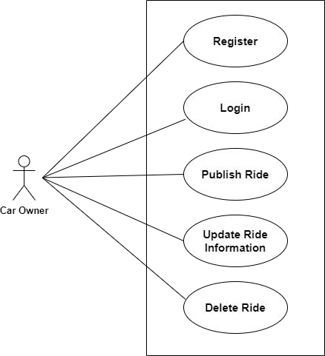

Fig. Use-Case Diagram for Car owner

## User:

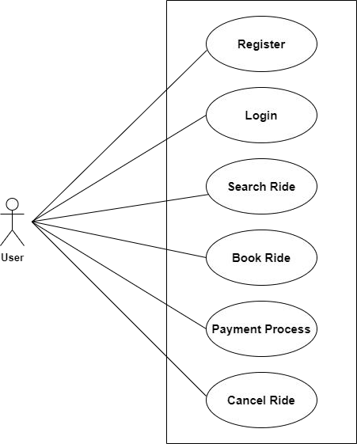

Fig. Use-Case Diagram for User

### Admin:

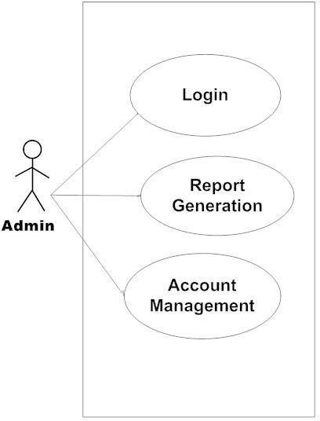

Fig. Use-Case Diagram for Admin

# Database Design:

1. **Role**

|  |  |  |  |  |  |
| --- | --- | --- | --- | --- | --- |
| **Field** | **Type** | **Null** | **Key** | **Default** | **Description** |
| id | Integer | No | Primary key | Null | Role ID |
| role | Varchar(45) | No |  | Null | Which type of user is enrolled. |

1. **Login**

|  |  |  |  |  |  |
| --- | --- | --- | --- | --- | --- |
| **Field** | **Type** | **Null** | **Key** | **Default** | **Description** |
| id | Integer | No | Primary key | Null | Which type of user logged in |
| roll_id | Integer | No | Foreign key | Null | Reference to roll_id(Tbl Role) |
| login_id | Varchar(100) | No | Unique | Null | Login_id |
| password | Varchar(100) | No |  | Null | Password |
| status | Tinyint | No |  | Null | Login Status |

1. **Users**

|  |  |  |  |  |  |
| --- | --- | --- | --- | --- | --- |
| **Field** | **Type** | **Null** | **Key** | **Default** | **Description** |
| id | Integer | No | Primary key | Null | Car_owner/User |
| user_id | Integer | No | Foreign key | Null | reference to Login_id(Tbl_login) |
| password | Varchar(100) | No |  | Null | Password of user |
| aadhar_no | Varchar(45) | No |  | Null | Aadhar number of user |
| fname | Varchar(100) | No |  | Null | First name of User |
| lname | Varchar(100) | No |  | Null | Last name of User |
| gender | Varchar(45) | No |  | Null | Gender of User |
| dob | Date | No |  | Null | Date of Birth of User |
| licence | Varchar(45) | Yes |  | Null |  |
| phone-no | Varchar(45) | No |  | Null | Phone no of User |
| primary email | Varchar(100) | No |  | Null | email id of User for login |
| secondary_e mail | Varchar(100) | Yes |  | Null | Secondary email id of User |

1. **Co_passenger**

|  |  |  |  |  |  |
| --- | --- | --- | --- | --- | --- |
| **Field** | **Type** | **Null** | **Key** | **Default** | **Description** |
| id | Integer | No | Primary key | Null | Co-passenger ID |
| passenger_id | Integer | No | Foreign key | Null | Reference to User_id (Tbl_User) |
| aadhar_no | Varchar(45) | No |  | Null | Aadhar no of co_passenger |
| phone_no | Varchar(45) | Yes |  | Null | Phone no of co_passenger |
| email | Varchar(45) | Yes |  | Null | Email of co_passenger |
| fname | Varchar(45) | No |  | Null | First name of co_passenger |
| lname | Varchar(45) | No |  | Null | Last name of co_passenger |
| Gender | Varchar(45) | No |  | Null | Gender of co_passenger |

# Car_company

|  |  |  |  |  |  |
| --- | --- | --- | --- | --- | --- |
| **Field** | **Type** | **Null** | **Key** | **Default** | **Description** |
| id | Integer | No | Primary key | Null | Admin ID |
| company_name | Varchar(100) | No |  | Null | Company name of car |

# Car_Models

|  |  |  |  |  |  |
| --- | --- | --- | --- | --- | --- |
| **Field** | **Type** | **Null** | **Key** | **Defa ult** | **Description** |
| id | Integer | No | Primary key | Null | Admin ID |
| Company_id | Integer | Yes | Foreign_key | Null | Reference to  Car_company_id(Tbl_**Car_company**) |
| model_name | Varchar(100) | No |  | Null | Model name of car |
| fuel_type | Varchar(100) | No |  | Null | Fuel type of car |
| model_type | Varchar(100) | No |  | Null | Model type of car |

# Vehicles

|  |  |  |  |  |  |
| --- | --- | --- | --- | --- | --- |
| **Field** | **Type** | **Null** | **Key** | **Defa ult** | **Description** |
| id | Integer | No | Primary key | Null | Vehicle id |
| carowner_id | Integer | No | Foreign key | Null | Reference to Users_id(Tbl_**users**) |
| model_id | Integer | No | Foreign key | Null | Reference to  Car_Model_id(Tbl_c**ar_model_**) |
| year | Integer | No |  | Null | Year of buying car |
| color | Varchar(45) | No |  | Null | Color of car |
| rc-book | Varchar(200) | No |  | Null | Registration card of car owner |

1. **Rides**

|  |  |  |  |  |  |
| --- | --- | --- | --- | --- | --- |
| **Field** | **Type** | **Null** | **Key** | **Default** | **Description** |
| id | Integer | No | Primary key | Null | Ride Id |
| carowner_id | Integer | No | Foreign key | Null | Reference to  Carowner_id(Users_Tbl) |
| start_Location | Integer | No | Foreign key | Null | Reference to Cid (Tbl_City) |
| end_Location | Integer | No | Foreign key | Null | Reference to Cid (Tbl_City) |
| vehicle_id | Integer | No | Foreign key | Null | Reference to Vid (Tbl_Vehicle) |
| time_of_departu re | Time | Yes |  | Null | Time of departure |
| time_of_arival | Time | Yes |  | Null | Arrival time |
| price_per_seat | Integer | No |  | Null | Price per seat amount |
| Available_seats | Integer | No |  | Null | Total available seats in car |
| status | Varchar(1 00) | Yes |  | Null | Ride is confirmed or not |
| date_of_journey | Date | Yes |  | Null | Date of Journey |

1. **Booking**

|  |  |  |  |  |  |
| --- | --- | --- | --- | --- | --- |
| **Field** | **Type** | **Nul l** | **Key** | **Default** | **Description** |
| id | Integer | No | Primary key | Null | Booking ID |
| passenger_id | Integer | No | Foreign key | Null | Reference to passenger_id(Tbl_User) |
| ride_id | Integer | No | Foreign key | Null | Reference to Ride_id(Tbl_Ride) |
| time | DateTime | No |  | Null | Booking time |
| no_of_seats | Integer | No |  | Null | How many seats are booked |
| total_price | Integer | No |  | Null | Total price acc to passenger |
| status | Varchar(100) | Yes |  | Null | Status of booking confirmation or not |

1. **Payment**

|  |  |  |  |  |  |
| --- | --- | --- | --- | --- | --- |
| **Field** | **Type** | **Nu ll** | **Key** | **Default** | **Description** |
| id | Integer | No | Primary key | Null | Payment ID |
| booking_id | Integer | No | Foreign key | Null | Reference to  Booking_id(Tbl_Booking) |
| passenger_id | Integer | No | Foreign key | Null | Reference to  passenger_id(Tbl_Co_passenger) |
| amount | Integer | No |  | Null | Total amount |
| Date_Time | Datetime | No |  | Null | Date and time of payment |
| payment_met hod | Varchar(4 5) | No |  | Null | Permanent method |
| status | Varchar(1 00) | No |  | Null | Paymnt is succesfull or not |

1. **State**

|  |  |  |  |  |  |
| --- | --- | --- | --- | --- | --- |
| **Field** | **Type** | **Null** | **Key** | **Default** | **Description** |
| id | Integer | No | Primary key | Null | State id |
| state | Varchar(45) | No |  | Null | State name |

1. **City**

|  |  |  |  |  |  |
| --- | --- | --- | --- | --- | --- |
| **Field** | **Type** | **Null** | **Key** | **Default** | **Description** |
| id | Integer | No | Primary key | Null | City id |
| city | Varchar(45) | No |  | Null | City name |
| state_id | Integer | No |  | Null | Reference to State_id(Tbl_State) |

# Passenger_review

|  |  |  |  |  |  |
| --- | --- | --- | --- | --- | --- |
| **Field** | **Type** | **Null** | **Key** | **Default** | **Description** |
| id | Integer | No | Primary key | Null | City id |
| passenger_id | Integer | No | Foreign key | Null | Reference to User_id(Tbl_User) |
| ride_id | Integer | No | Foreign key | Null | Reference to Ride_id(Tbl_Ride) |
| rating | Decimal(3, 2) | No |  | Null | Rating given by user to car_owner. |
| comments | Varchar(10 0) | Yes |  | Null | Any comments. |

# ER-Diagram:

# E-R diagram shows database of Inter-city Car Pooling System

# Snapshots:

* 1. **Home Page:**

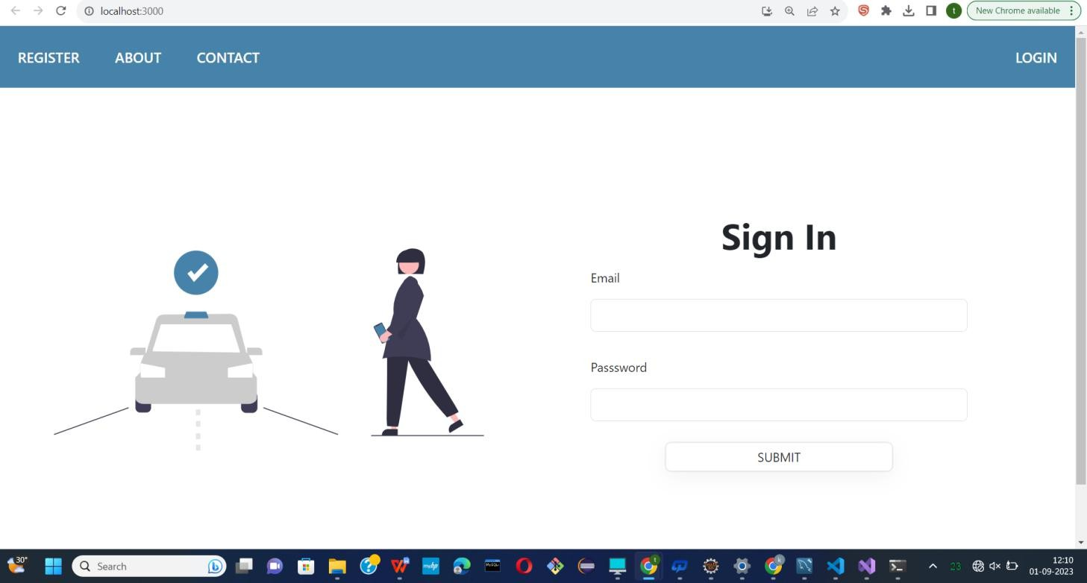

* Following snapshot shows the Home page of Inter-city Car Pooling System.

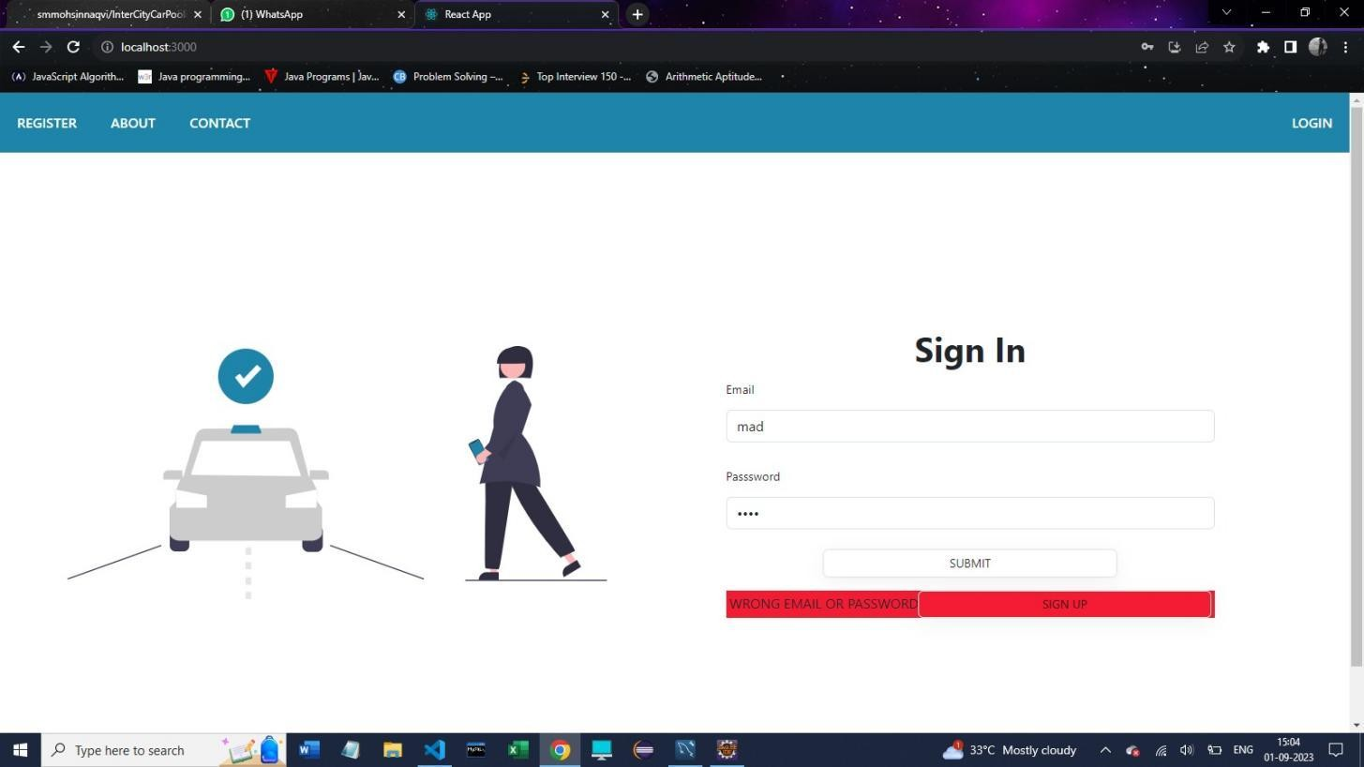



# Registration of user and car-owner both can registered here.

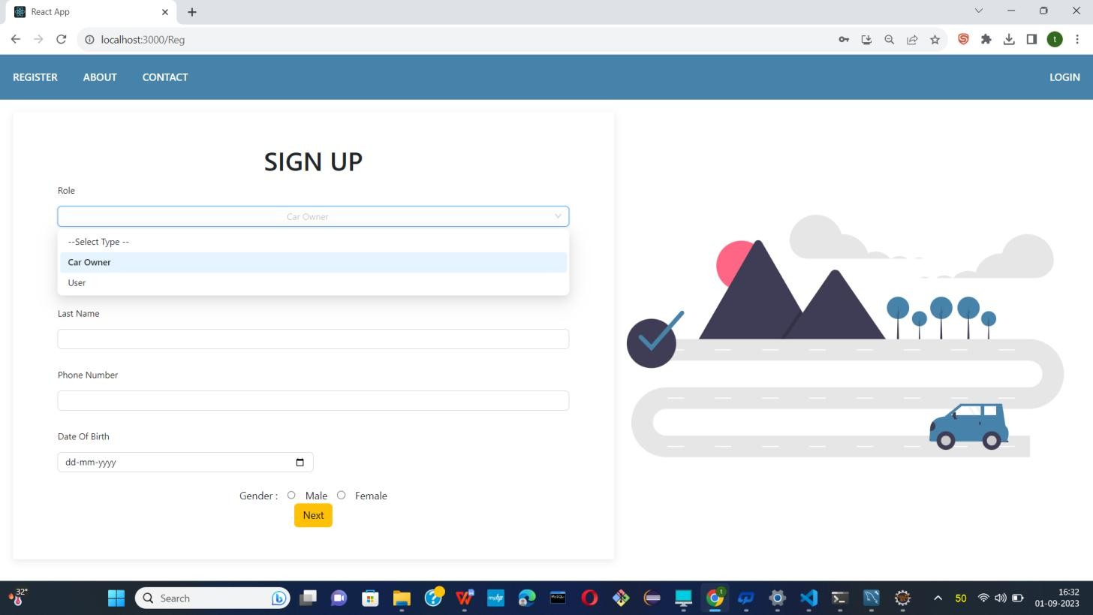

Selecting type of User

* 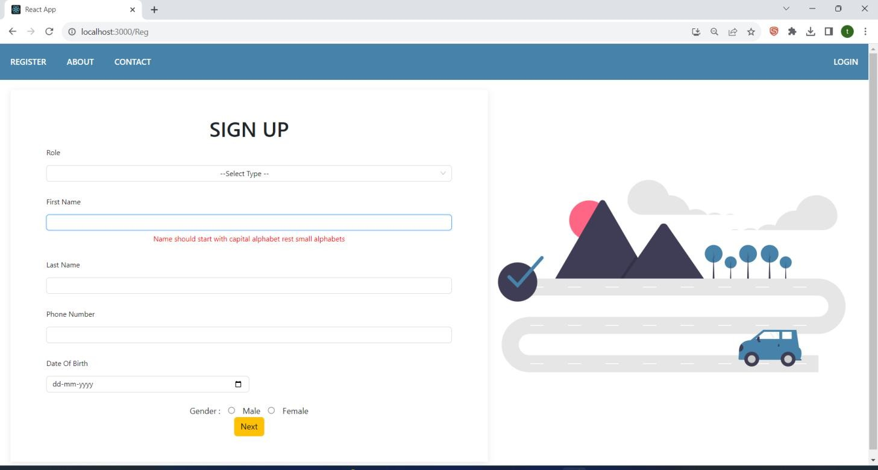

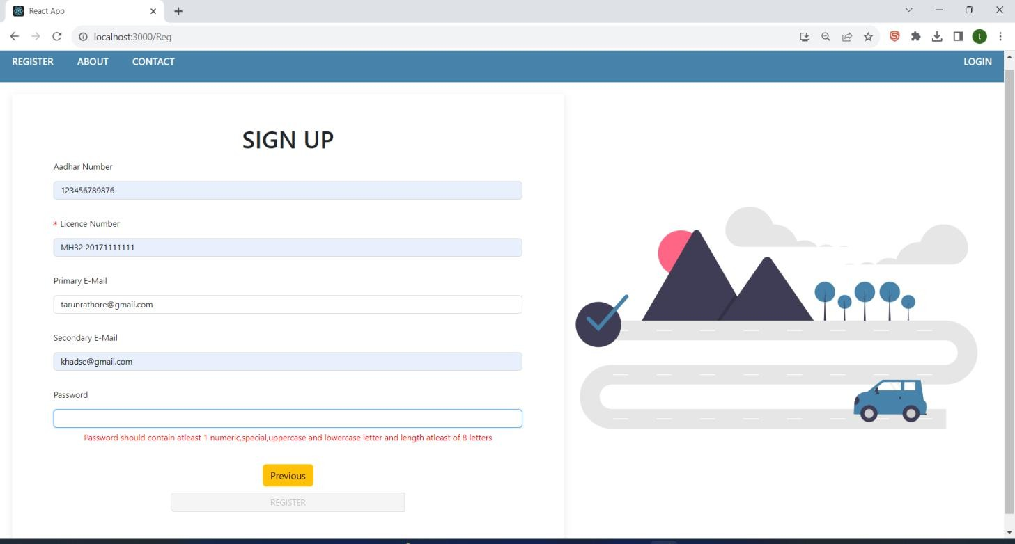

Validation on all required fields

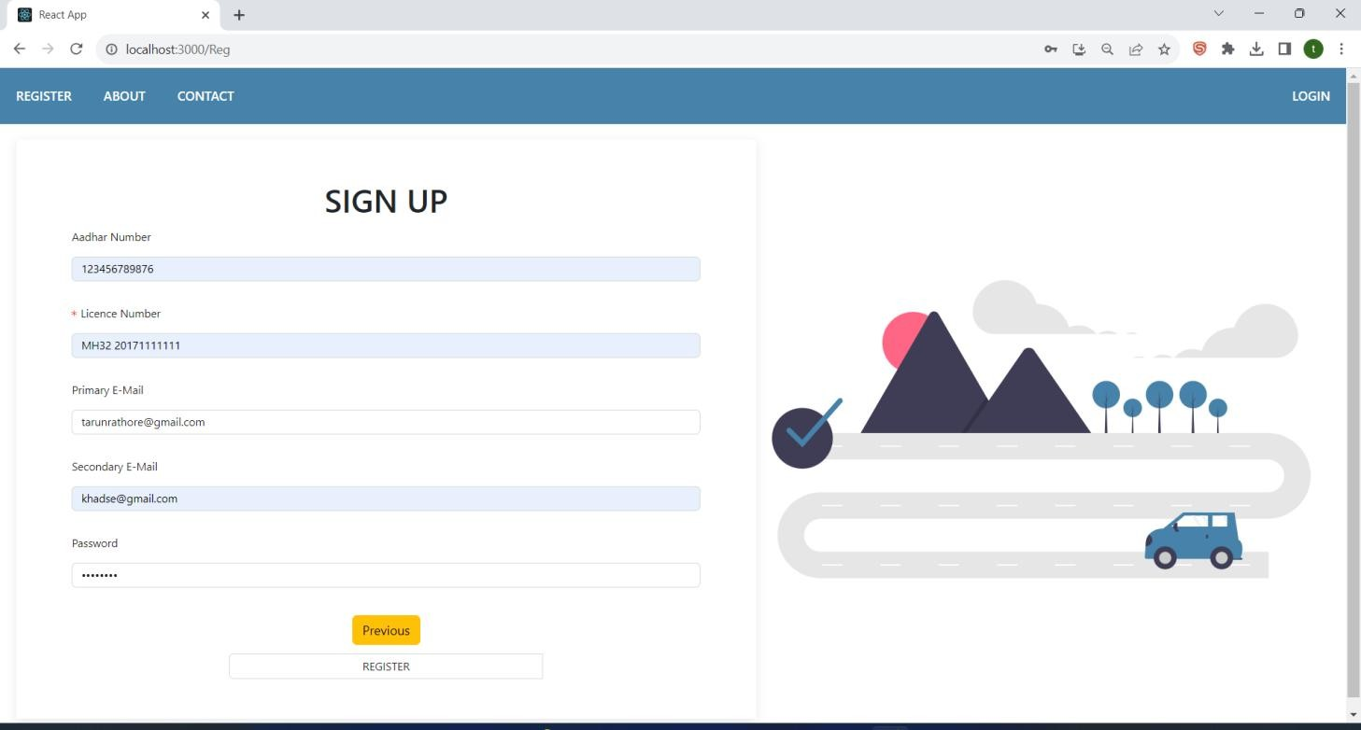

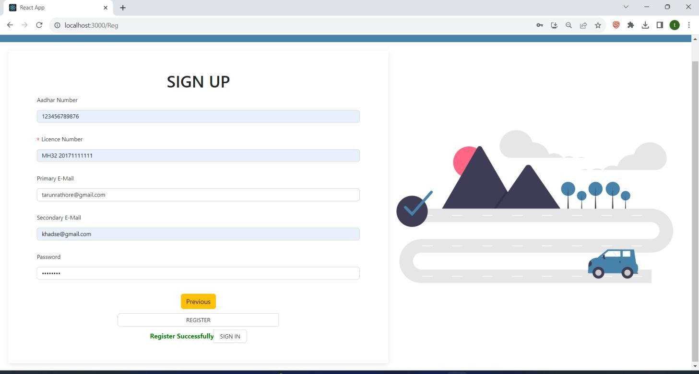

Registered Successfully.

* 1. Need Approval by **Admin**

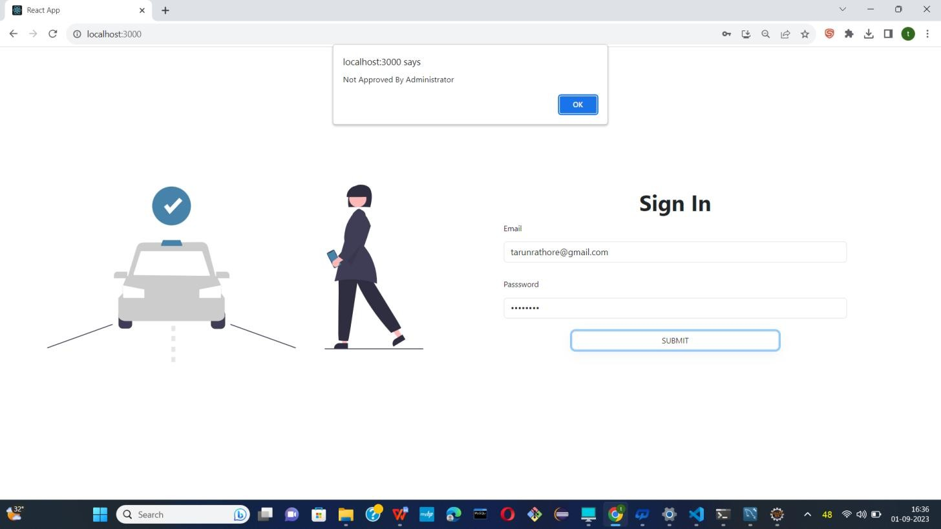

* Login as **Admin**

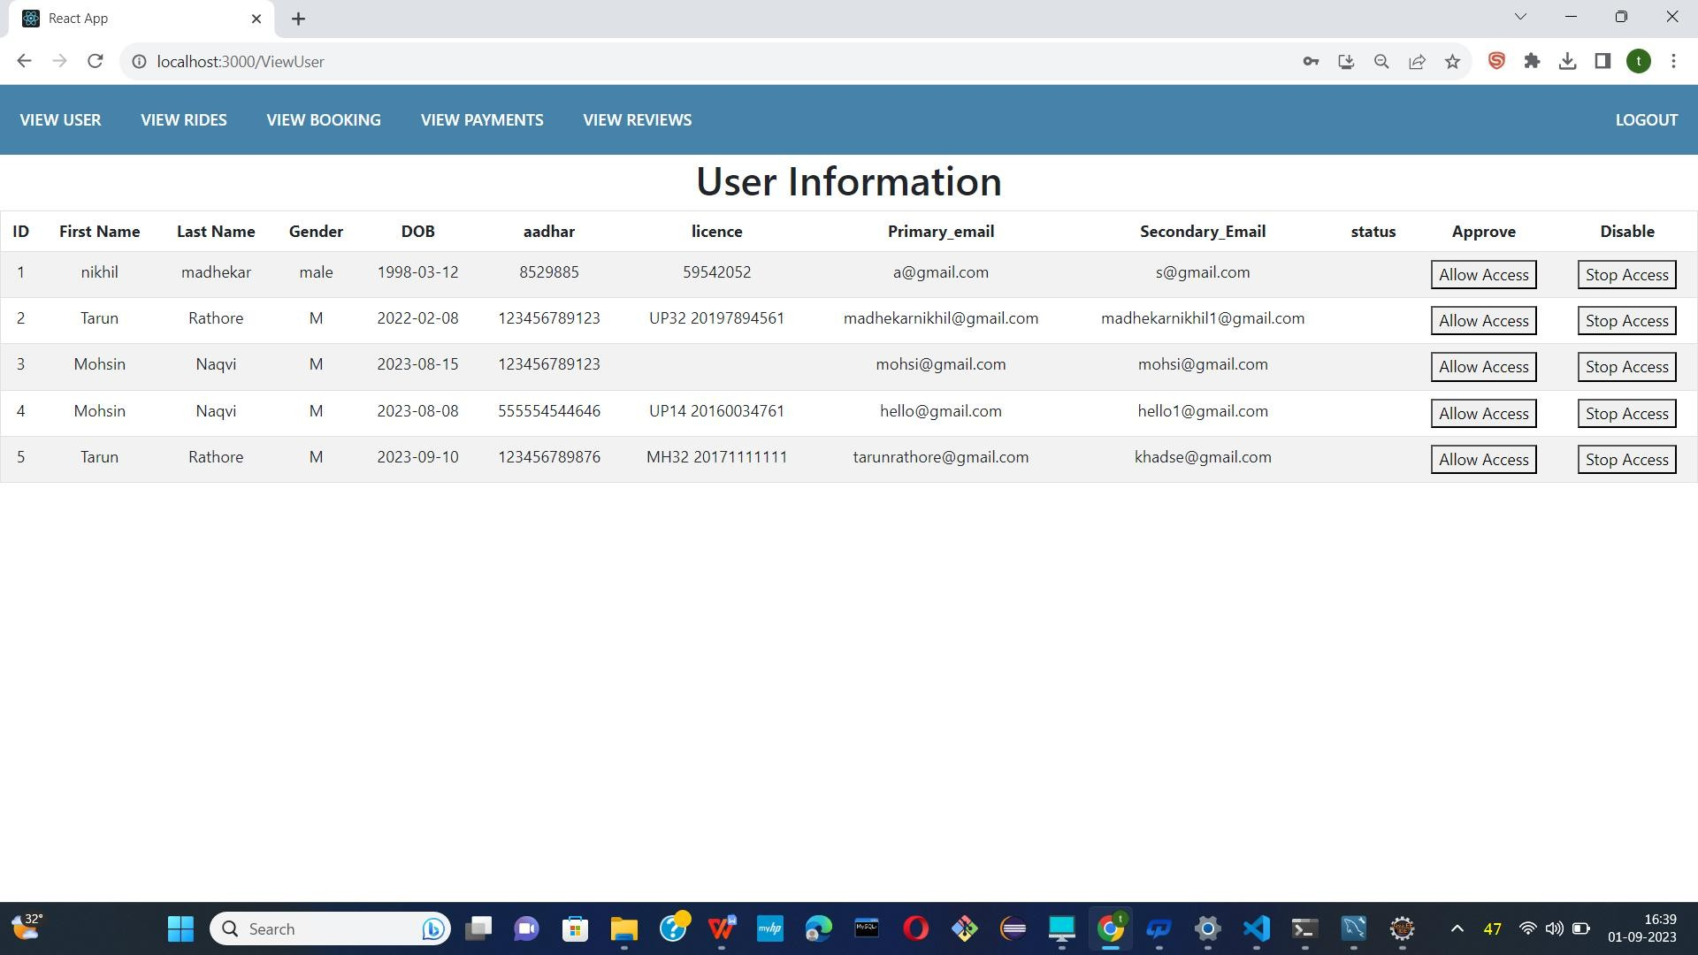

* Now Admin allow access New Car owner.

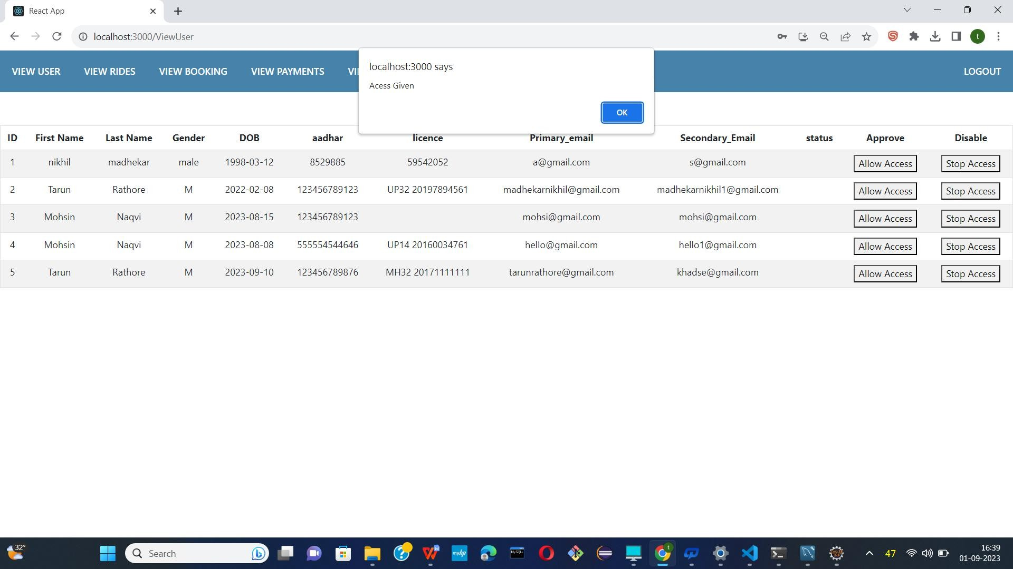

* Access allow.

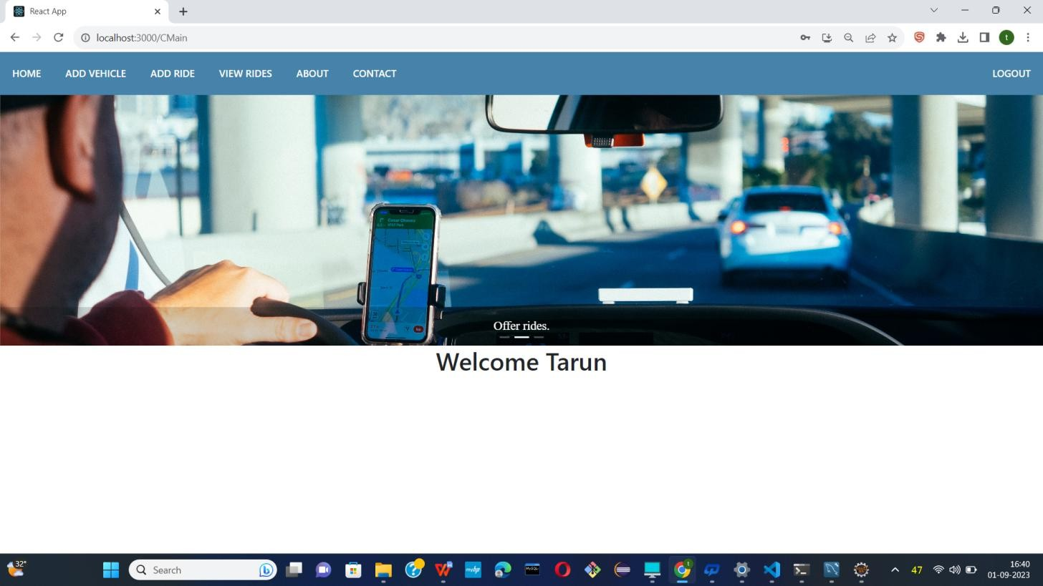

* Login as a Car owner

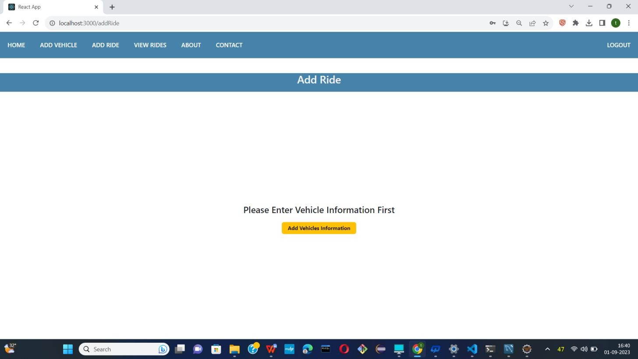

* Car-owner add vehicle information first.

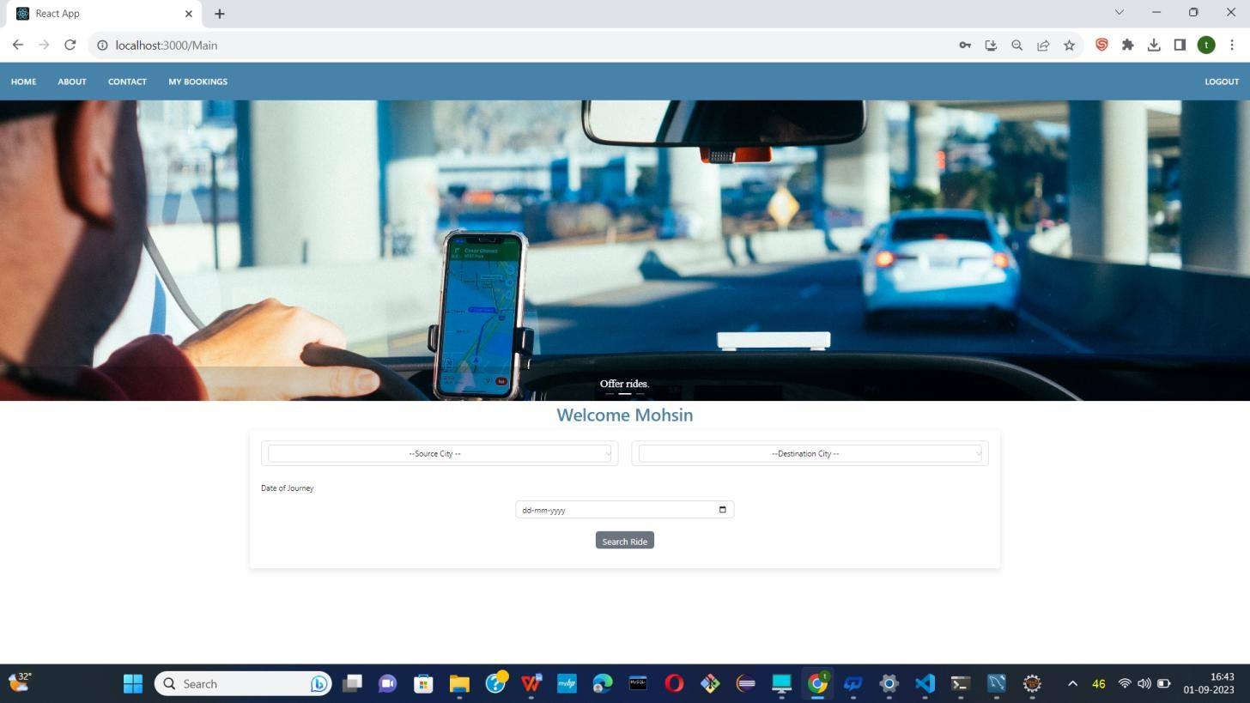

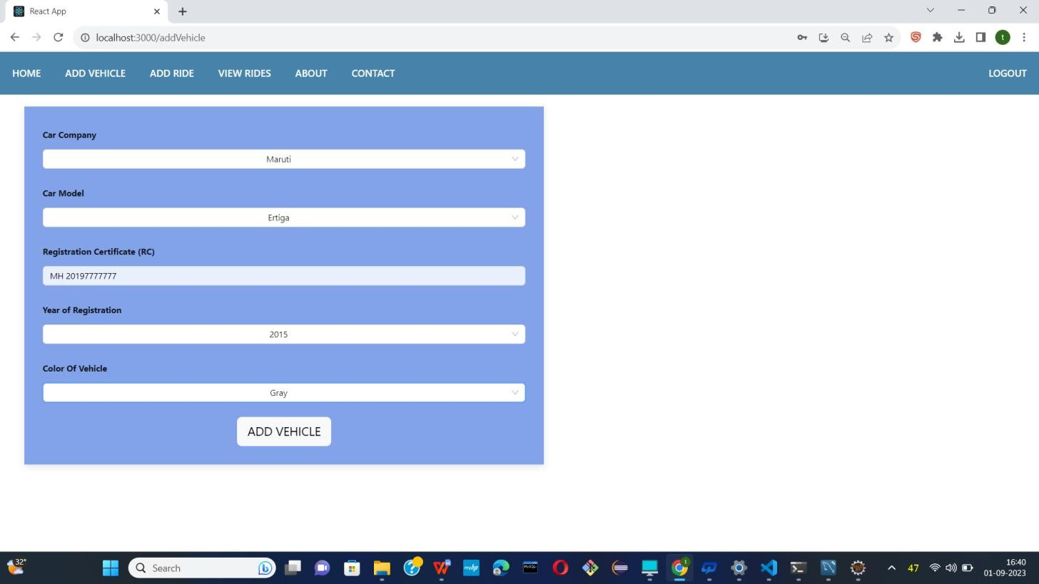

* Add vehicle information.

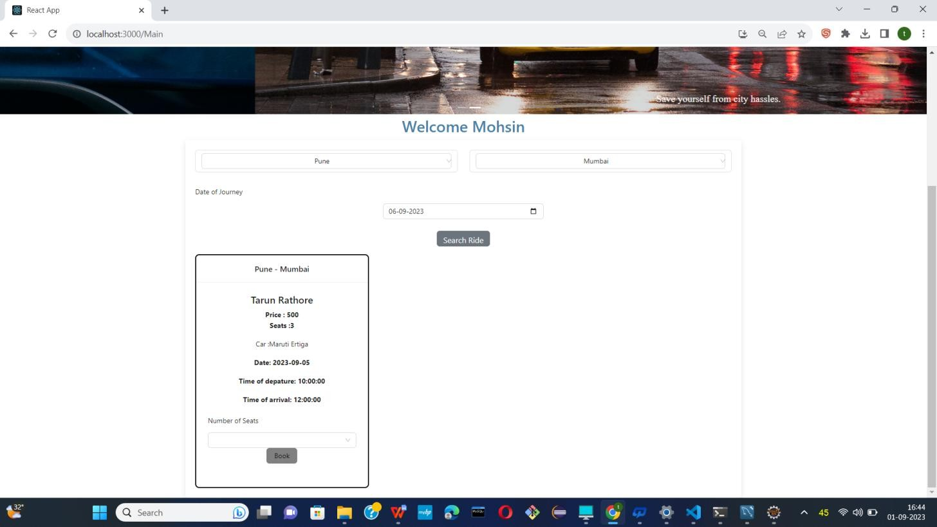

* 1. Login as a User and can search ride.

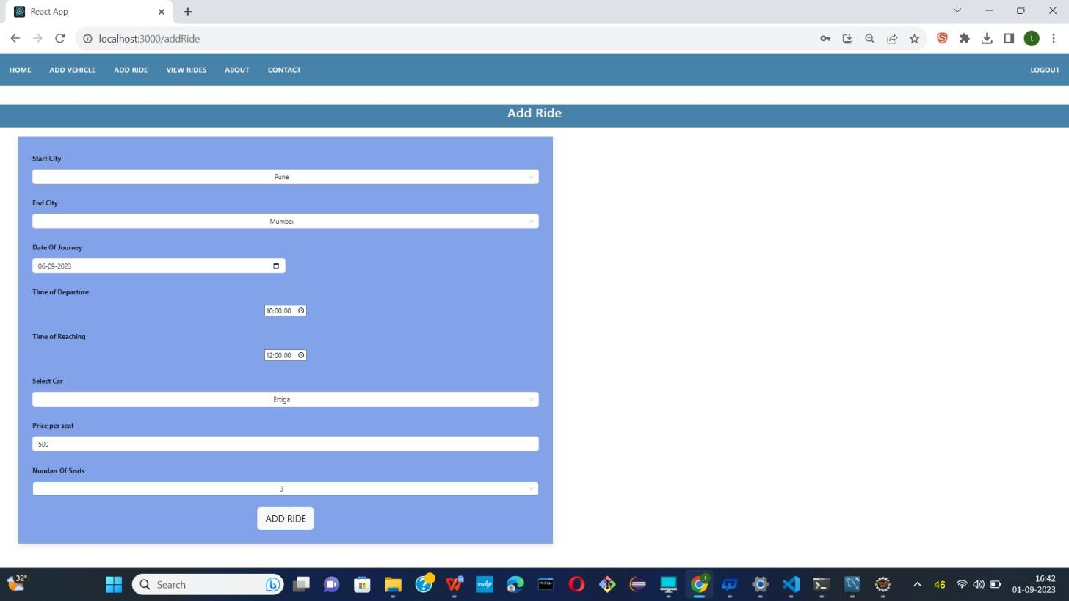

* Create ride information.

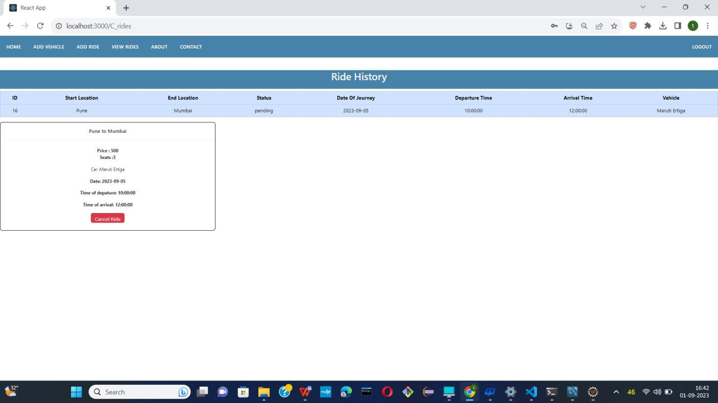

* User can shows his previous ride as as well.

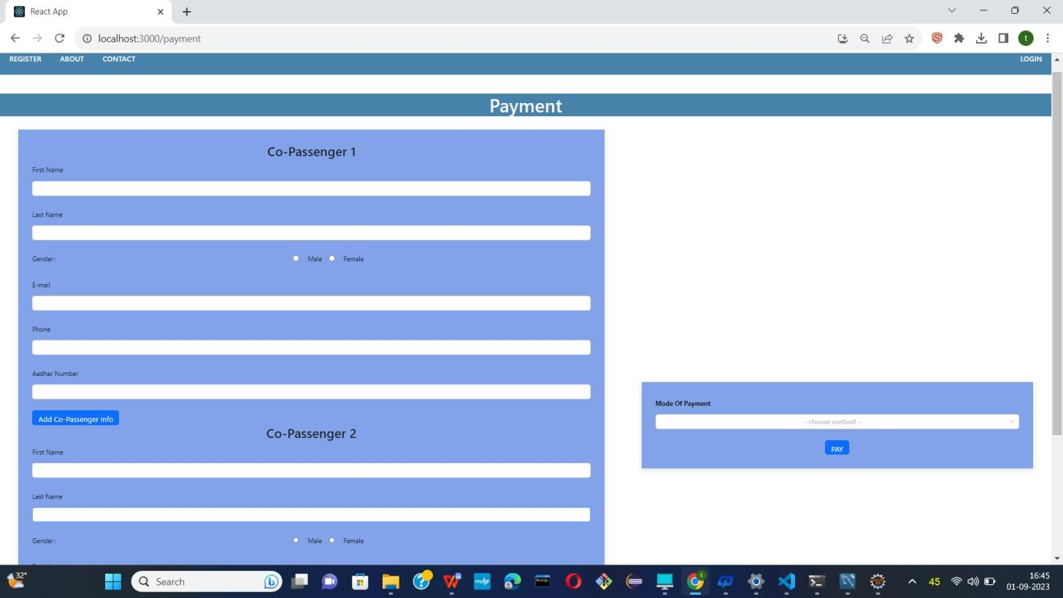

* Now users can add co-passenger as well with his ride .

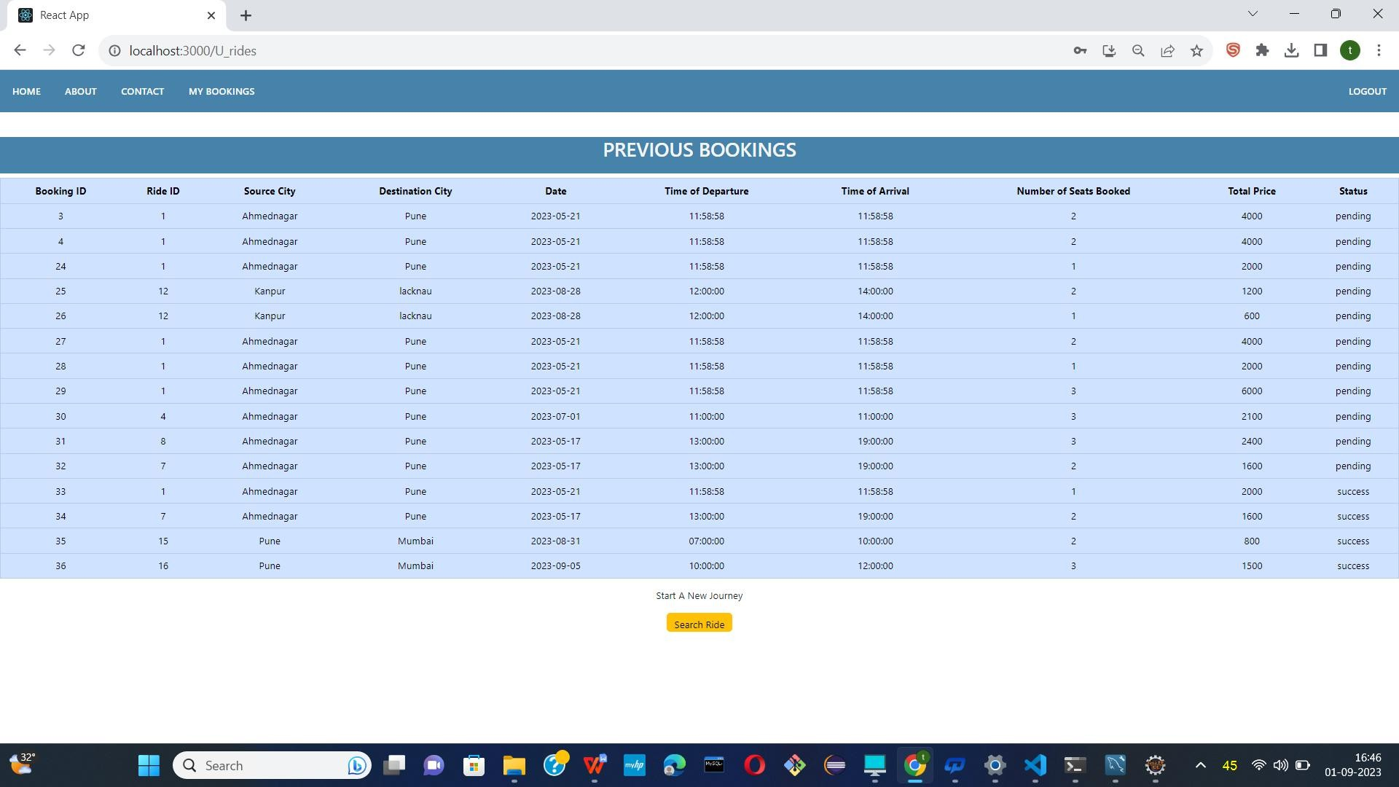

* Now users also shows their previous booking as well.

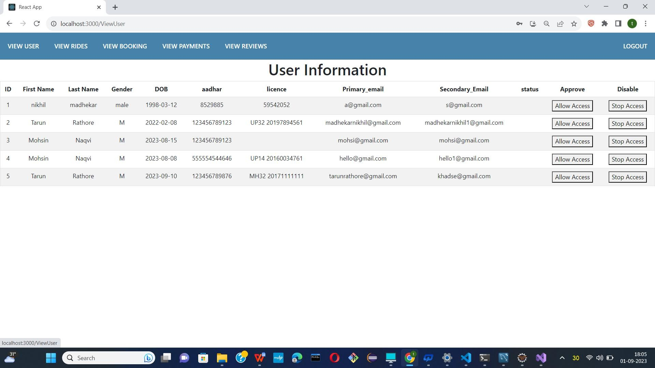

* Logged in as an Admin

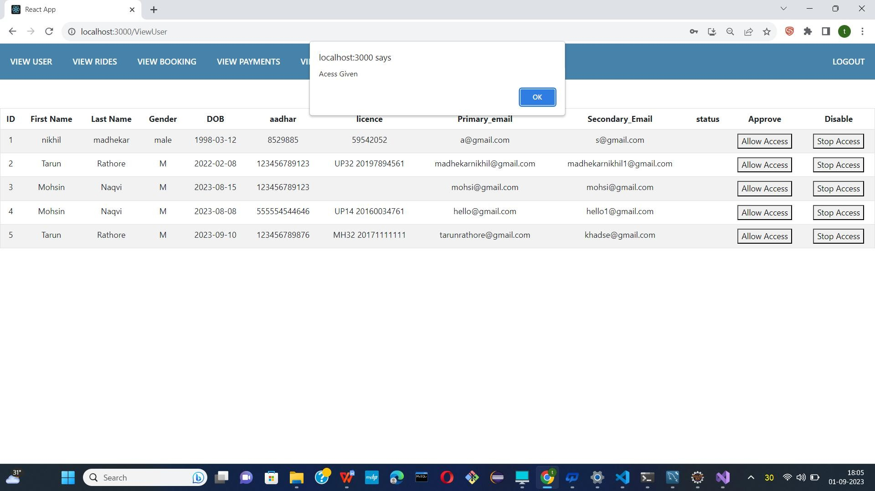

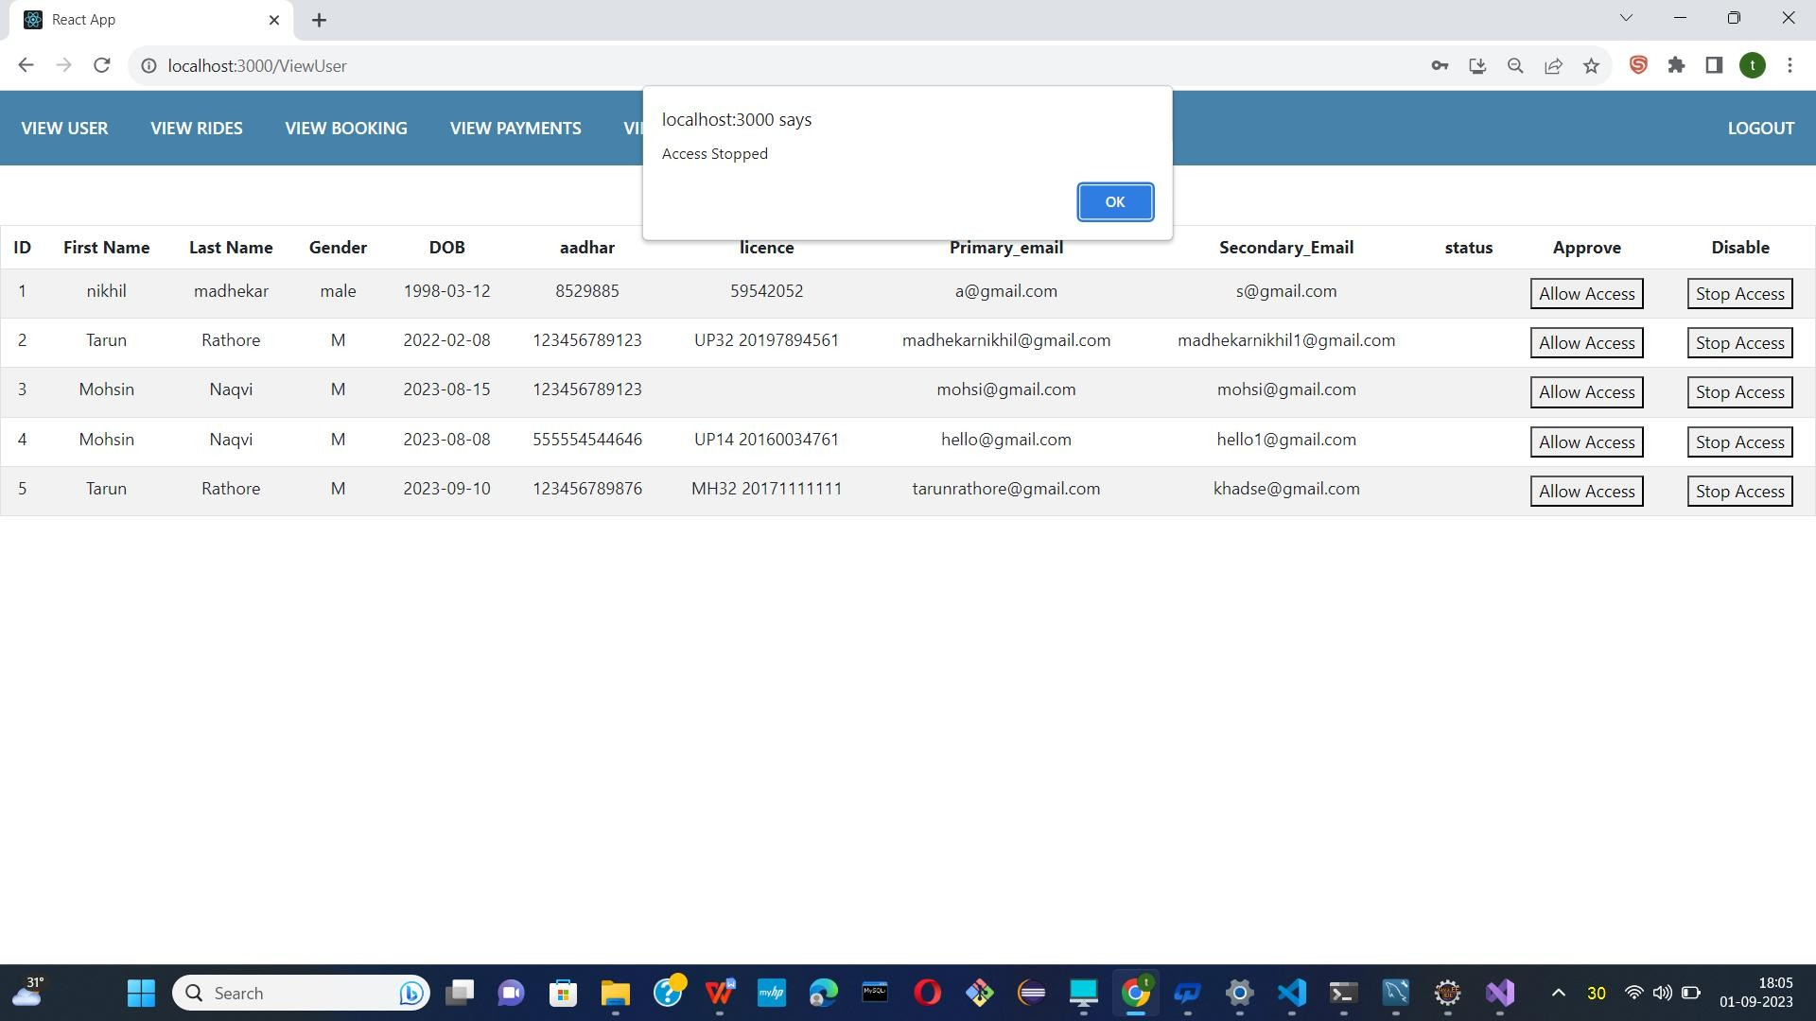

* Now admin had to Allow access and stop access to users.

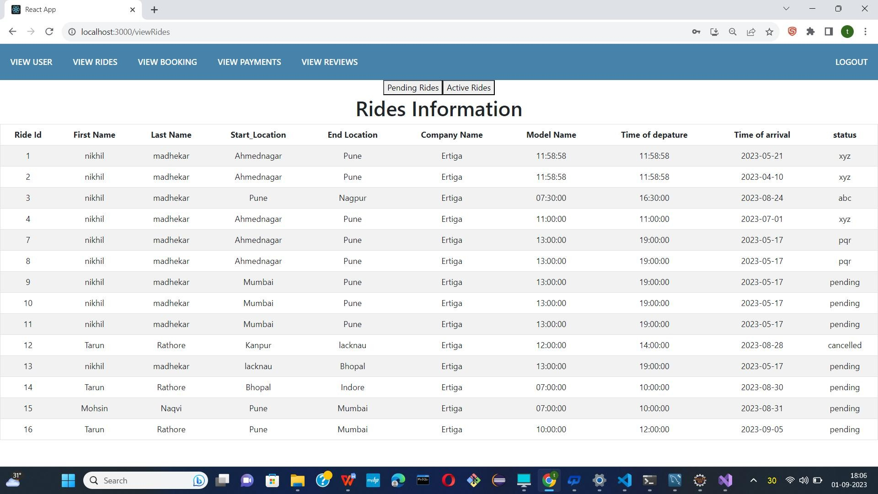

* Show all rides information.

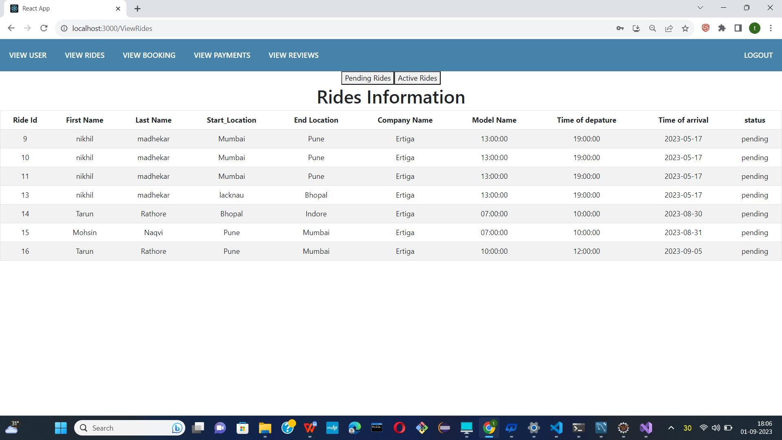

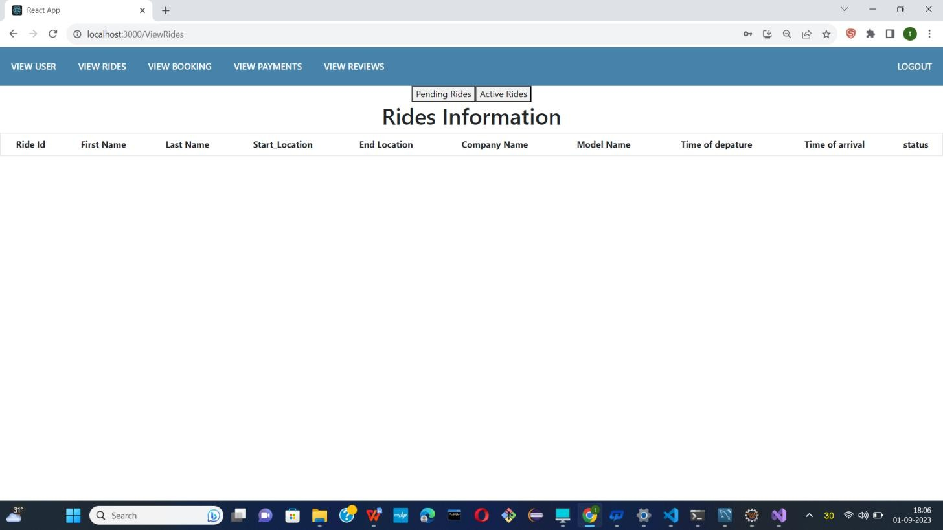

* Show all pending rides and active rides.

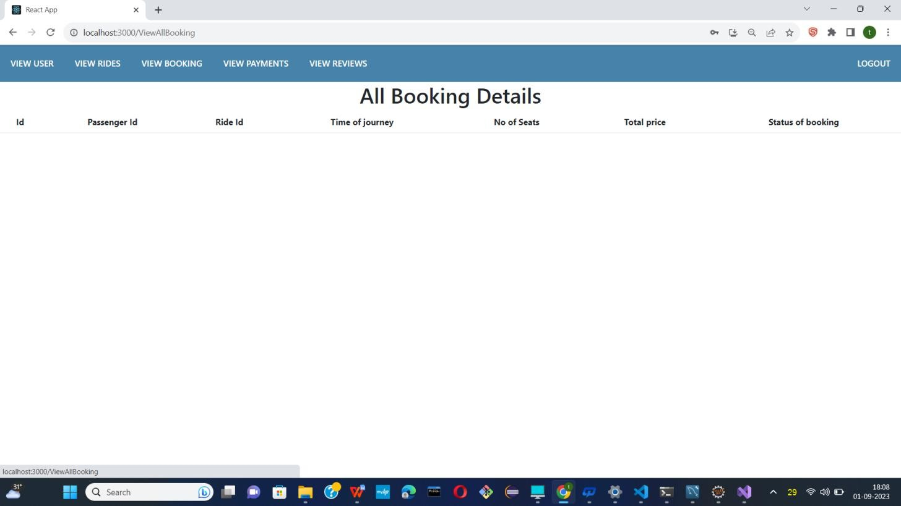

* Show all booking information.

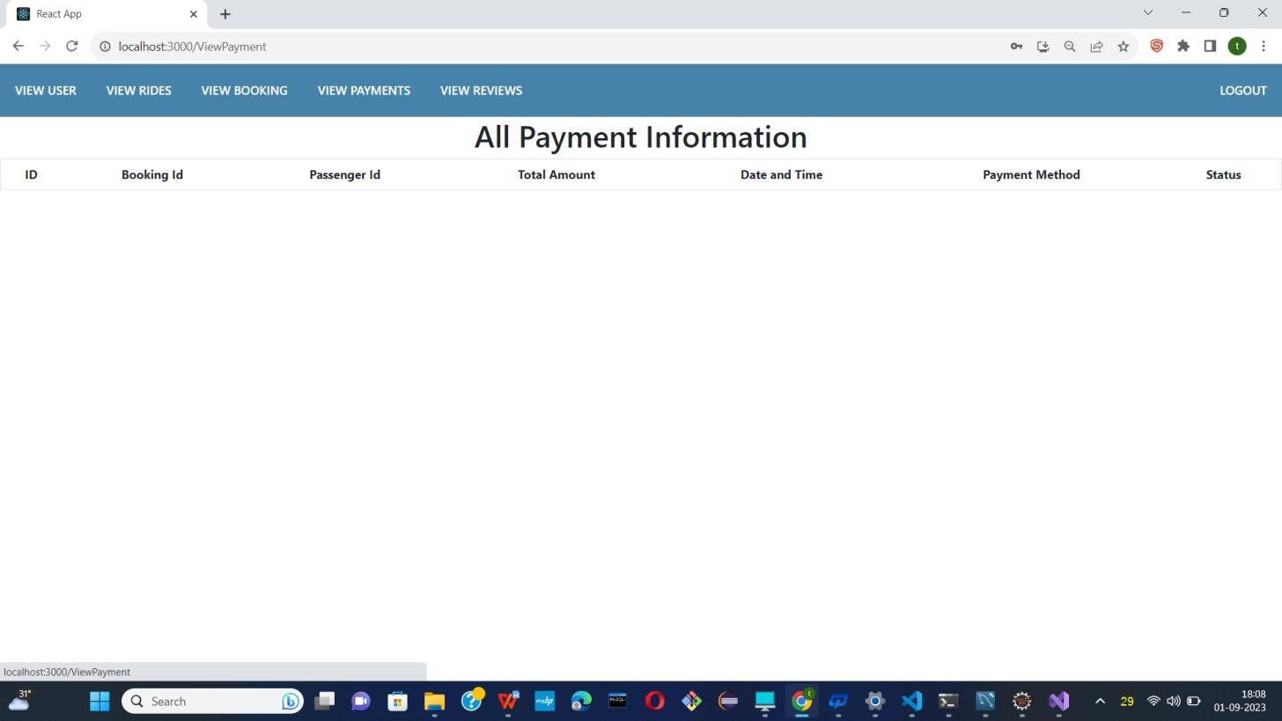

* Show all payment information.

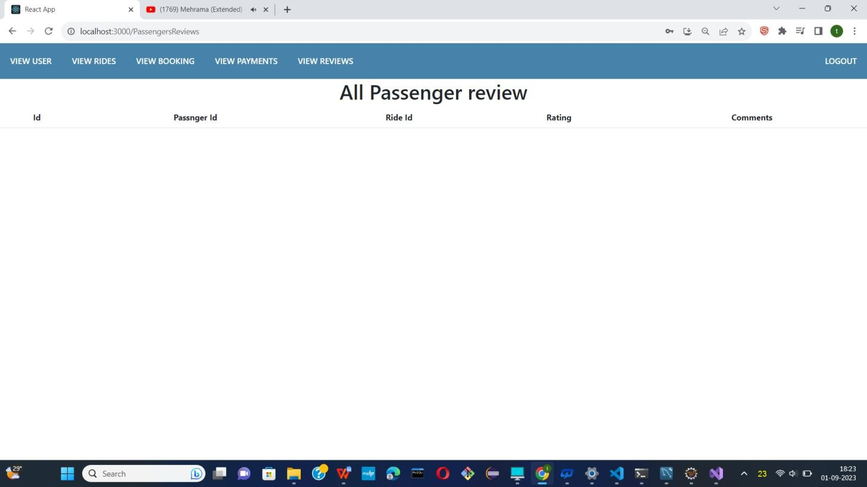

* Show all passenger review.

**9. CONCLUSION AND FUTURE SCOPE**

* Swift Rides is the sharing of car journeys so that more than one person travels in a car, and

prevents the need for others to have to drive to a location themselves with own car.

* Reduce traffic congestion – The benefits of carpooling on a large scale are huge.
* The software is flexible enough to be modified and implemented as per future requirements. We have tried our best to present this free and user–friendly website to Society.